***STARWEE***

**Bitcoin Organization Builder**

BoB v0.1.2 inside

01.2024/828380

@tetakta

Hello, world!

The world that is fixed by Bitcoin. Humanity already has the technology for reliable, transparent, and automated exchange of values and information, this is Bitcoin and Bitcoin technology.

It provides us with not only new money, but something much more.

We are trying to implement the necessary functions of Bitcoin programming (money) and the value exchange system right now.

We need a simple interface, an application that allows you to interact with Bitcoin. Introducing STARWEE:

**Simplify and automate your Bitcoin transactions with our easy-to-use, script-driven organizational finance app**

**What is STARWEE** ?

Starwee is a specialized platform designed for streamlining Bitcoin-based financial operations within organizations. It serves as a versatile tool for creating and managing automated Bitcoin transaction scripts, facilitating efficient value exchange systems. Starwee's straightforward interface allows users to easily program and execute Bitcoin transactions, making it an essential tool for organizations looking to integrate Bitcoin into their financial workflows. This solution focuses on simplifying the complexities of Bitcoin scripting, offering an accessible approach to leveraging cryptocurrency technology in business contexts.

**What is under the hood?**

What exactly does transaction and address automation and programming look like?

Under the hood of Starwee, transaction and address automation primarily hinge on Bitcoin's mainnet and its scripting capabilities. The core functionality is built upon simple Bitcoin scripts, which are the foundational blocks of the platform. Additionally, the system integrates a master key concept, rooted in Bitcoin's security principles, to enhance control and safety. While the initial version focuses on these fundamental elements, future expansions are planned to incorporate Discreet Log Contracts (DLCs) for more complex scripting and contract functionalities.

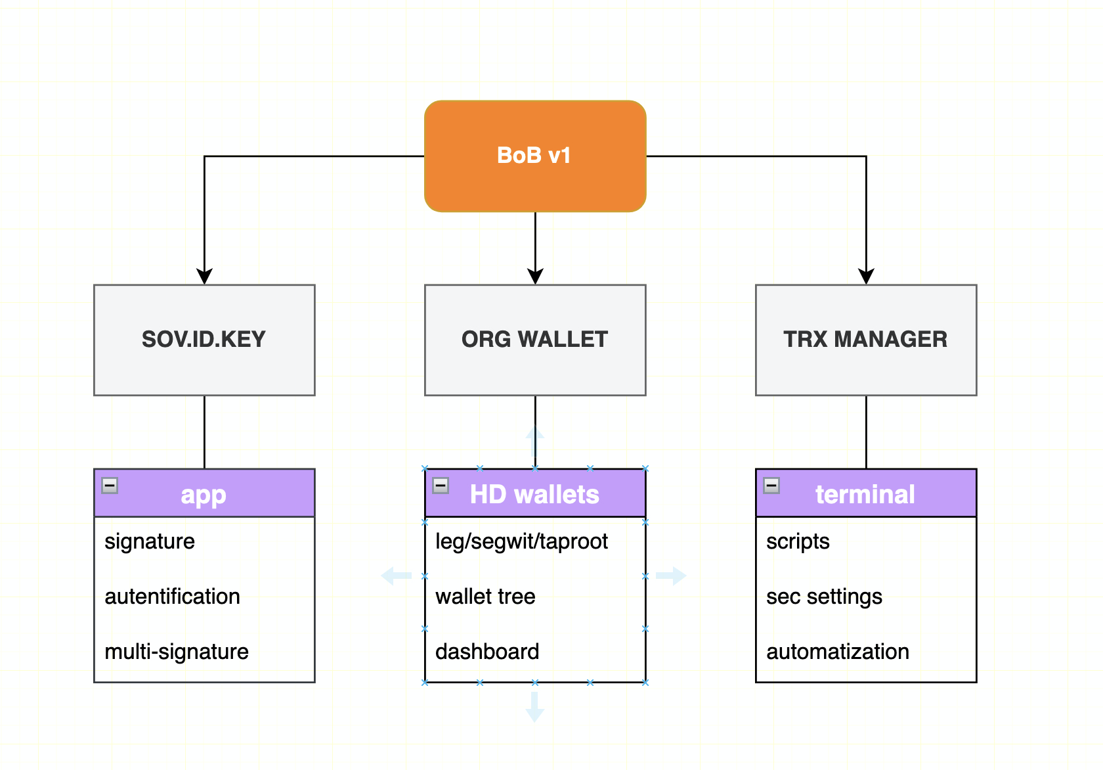

**Try STARWEE**

Browser-based environment for users to experience the STARWEE platform firsthand. Through this feature, users can engage in a step-by-step process to explore STARWEE's functionalities, including its Bitcoin transaction and scripting capabilities. This hands-on approach allows users to familiarize themselves with STARWEE's features, understand its integration with Bitcoin mainnet, and experiment with simple Bitcoin scripts and master key functionalities, providing a practical and insightful introduction to the platform's capabilities.

**Key Features**

**Automated Bitcoin Transaction and Script Creation**: Simplify complex Bitcoin transactions with user-friendly script automation.

**Integration with Bitcoin Mainnet**: Ensures secure and authentic transactions directly on the blockchain.

**Master Key Functionality**: Enhanced security and control over transactions and wallet access.

**Simple Bitcoin Scripting**: User-friendly interface for creating and managing Bitcoin scripts.

**Future DLC Integration**: Plans for advanced contract and scripting capabilities in upcoming versions.

**Intuitive User Experience**: Streamlined interface designed for ease of use, catering to both beginners and advanced users.

**Robust Security Architecture**: Built on a foundation of strong encryption and secure key management practices.

**Adaptable to Organizational Needs**: Customizable features to suit various business models and financial operations.

**For more details, please follow the links:**

Business model

Market analysis

Technical description



2024

Ukraine